|  |
| --- |
| Photo displaying partial image of two pie charts on a canvas-textured page |
| Clear Thinking Clinic  Presented by THIN YANANT NWAY |
| |  |  |  | | --- | --- | --- | | NVL Institute |  | Computer Networks | |



**NCC Education**

**LEVEL 4 DIPLOMA IN COMPUTING**

**COMPUTER NETWORKS**

|  |
| --- |
| Centre Name : NVL INSTITUTE  Assignment Title : CLEAR THINKING CLINIC  Exam Cycle : DECEMBER 2018  Candidate Name : THIN YANANT NWAY  NCC Education ID No : 00176348  Submission Date : 31.Oct.2018 |
| Marker’s Comments :  Moderator’s Comments :  Mark: Moderated Mark: Final Mark: |



**Statement and Confirmation of Own Work**

***Each time you submit an assignment you must attach this statement as the cover page for both the hard copy and the electronic version. If the statement is missing, your work will not be marked.***

**Student Declaration**

I have read and understood NCC Education’s Policy on Academic Dishonesty and Plagiarism.

I can confirm the following details:

**Programme/Qualification Name** : LEVEL 4 DIPLOMA IN COMPUTING

**Student ID/Registration Number** : 00176348

**Name**  : THIN YANANT NWAY

**Centre Name** : NVL INSTITUTE

**Module Name**  : COMPUTER NETWORKS

**Module Leader** : U MIN THU KHANT

**Number of words** :

I confirm that this is my own work and that I have not plagiarized any part of it. I have also noted the assessment criteria and pass mark for assignments.

**Due Date** : 31. Oct.2018

**Student Signature**  : **Nway**

Submitted Date : 31. Oct.2018

Contents

INTRODUCTION 5

ACKNOWLEDGEMENT 6

Task1: Network Infrastructure and Protocols 8

(a) 8

(b) OSI 7-layer Model 8

(c) Seven Protocols 8

(d) Hub, Switch, Wireless Access Point, Router 8

Task 2: Addressing 10

(a)Network Address and Host Address 10

(b)Private IPV4 and Public IPV4 Address 10

(c)DHCP 10

(d)Difference between IPV4 & IPV6 10

(e)Gateway 10

(f)Subnet mask 10

(g)IP Routing 10

Task 3: Security 12

(a)Three Main Security concepts 12

(b) 12

(c) 12

(d) 12

(e) 12

Task 4: Diagram and Explanation 15

(a)Logical Network Diagram 15

(b) 15

(c) 15

(d)Local Price and Specification of Hardware and Software 15

Task 5: Telephony 17

(a)What is VOIP? 17

(b) 17

(c) 17

CONCLUSION 18

REFERENCE 19

# INTRODUCTION

My name is Thin Yanant Nway. I am a student of the level 4 Diploma in Computing in NVL Institute Mandalay. I’m studying in the second module, I studied 4 subjects in first module; "Database, Designing and Developing a Website, Office Solutions Development and Designing and Developing Object-Oriented Computer Programs and in this second module, I study another 4 subjects; “Computer Networks, Computer Systems, Skill for Computing, Software Development Technology.

This assignment is to open a new clinic in Cambridge.

# ACKNOWLEDGEMENT

Thank you…………..

TASK-1

# Task1: Network Infrastructure and Protocols

## (a)

## (b) OSI 7-layer Model

OSI 7 layer are

1. Physical
2. Data Link
3. Network
4. Transport
5. Session
6. Presentation
7. Application

**Physical Layer**

In seven-layer OSI model of computing networking; the physical layer is the first and it also the lowest layer of networking. It consists of electronic circuit that can transmit network of technology. The electrical impulses; light or radio signal are pass the network at the both electrical and mechanical level. It translates logical communication requests from the data link layer into hardware-specific operation to cause electronic signal. And the popular machine or network applications liked Ethernet; Rs232 ATM are protocols with the physical layer.

**Data Link Layer**

The data link layer is the second layer of the seven-layer OSI model of computing networking. It is the protocol layer that transfer data between wide area network of adjacent node. It divides into two layers such as the media access control (MAC) and the logical link control (LLC). The data link layer is concerned nodes on the same level of the network between local delivery of farms. The two layers it links into are controlling a how computer on the network gains access to the data and permission to transmit it and another layer controlling frame synchronization; flow control and error checking.

**Network layer**

Is the third layer of the seven-layer OSI model of computer networking. It provides the technologies of switching and routing; creating logical paths which known as virtual circuit for transmitting data from node to node. This layer responds to service requests from the transport layer and issues service requests to data link layer. Routing and forwarding are the functions f this layer too. Liked addressing internetworking error handling congestion control and packet sequencing.

**Transport layer**

Is the fourth layer of the seven-layer OSI model of computer networking. It is the layer in the OSI middle responsible for end to end communication over a network. The transport layer has two common protocols that control transmission of protocol and the user datagram protocol. It is also ensuring complete data transfer.

**Session layer**

The session layer is the fifth of the seven-layer OSI model of compute networking. It manages and terminates two application while connecting. These two points if communication is called the connection and its also the role of the session layer. In computer science it interchanges include two or more than this communicating devices or computer user.

**Presentation Layer**

The presentation layer is the six layer of the seven-layer OSI model of computer networking. The main function its work includes many translations of character code; conversion of data and other kind of translation of data. This layer transforms the data into the form that which application layer can confirm. This layer can also call syntax layer and it is well defined and standard.

**Application Layer**

Application layer is the last layer of the seven-layer OSI model of computer networking. This layer is very popular in nowadays. Its can get allow in many Microsoft and electronic computing machine and phones. This layer supports application and processes for end users.This layer also transfers the application service for file like e-mail;other social media and software about networking series. The one application liked architectures are also the part of this layer4.

## 1(c) Seven Protocols

* UDP
* IP
* SMTP
* HTTP
* FTP
* POP3
* DHCP

UDP

UDP is a User Datagram Protocol that provision a little amount of network machine. It is used for transaction protocol layer. It can use for connected where a large number of customers.

IP

IP is the Internet Protocol that is a number of labels allocated to connect a computer network for each device. Internet Protocol is used for communication. IPv4 is 32 bits of number in IP address and IPv6 id 129 bits of number in IP address.

SMTP

SMTP is a Simple Mail Transfer Protocol that is an application layer of internet protocol. It is called a “store and forward” for using that process. IP protocol is used for send and accept an e-mail.

HTTP

HTTP is called Hyper Text Transfer Protocol. It is used World Wide Web for data communication. It can solve a message how to transform the format and transmit. It can also easy to transfer for hypertext.

FTP

FTP means File Transfer Protocol. On a computer network that can transfer of files between sever and client. Architecture is using a data connection that it is a client-server model.

POP3

POP3 is called Post Office Protocol 3. To downloading and mailing to mail server, it allows the email client. This is a very simple protocol , email, and any other features provided are not downloads.

DHCP

The meaning of DHCP is Dynamic Host Configuration Protocol. To communicate with multiple computers connected on the network addresses are set automatically. Connected to each of the two sets of dynamic and static devices.

## (d) Hub, Switch, Wireless Access Point, Router

Hub

Hub is the OSI model on the physical layer. Coming together in a star topology to connect to the data of the physical layer. It skills are not addressing. There can be internal bus or ring topology. The problem can be cut off to the node. E.g. Cable break and Flooding network with traffic.

Switch

Switch is the OSI model on the data link layer. Header to route messages based on address. Through the connection between the two ports, one open. It contains multiple switch ports. Individual computers are usually links to each port. To use a star topology network. All switch ports the incoming messages does not broadcast. The MAC table are based on the full bandwidth. There are two types of switch e.g. managed and unmanaged.

Wireless Access Point

Wireless access point (AP) adjacent to a cable from the local area network (LAN) connected to a group of wireless stations. One access point is similar to an Ethernet hub, but instead of the other LAN stations LAN relaying data to the access point connected to the LAN device (usually) is compatible with all other wireless devices to a single wireless data can be further Lwin. Other wireless devices on the LAN are allowed to communicate with any device, such as an Ethernet hub or switch. Wireless clients can join the wired Ethernet network. The home networking based on a broadband router can use to expand the network.

Router

Contact parts and a variety of often dissimilar networks Internetworking devices Internetwork. The OSI model, layer 3 devices in the Network layer. A message router can use software to select the output line. A function to manage the device. The routing algorithms is used to determine the next destination.

TASK-2

# Task 2: Addressing

## (a)Network Address and Host Address

## (b)Private IPV4 and Public IPV4 Address

Private IPV4

Private IPV4 address is one of the special address that is used to set aside by Internet Assigned Numbers Authority. And that is use for networks but it will not be co directly with Internet. This private IPV4 addresses cannot be used on the Internet and used for communicate with the Internet.

Public IP4

A public IP address is an [address](https://www.lifewire.com/what-is-an-ip-address-2625920) of IP. It’s your home or business [router](https://www.lifewire.com/what-is-a-router-2618162) from our [ISP](https://www.lifewire.com/internet-service-provider-isp-2625924). Public IP addresses are needed for any publicly network [hardware](https://www.lifewire.com/computer-hardware-2625895) for our home router as well as for servers that host websites.

## (c)DHCP

DHCP means Dynamic Host Configuration Protocol. It is a network protocol and it is used to dynamically appoint an Internet Protocol address for any node and any device. They can communicate with IP. DHCP automates and centrally manages configurations rather than required network administrators for manually assign IP addresses for all network devices. DHCP can be implemented on small local networks such as large enterprise networks.

## (d)Difference between IPV4 & IPV6

IPV4

IP4 Address is the version 4 of internet protocol. It’s used to classify device on network with the addressing system. Each IPV4 address is use 32 bits. It’s created of four decimal places between 0 and 255 separated by point. E.g. 1.115.21.245 should be address of IPV4.

IPV6

IPV6 address is the new addressing system that is version 6 of internet protocol. IPV6 address created of 128 bits. It’s created of hexadecimal with colon. E.g. 2ggt: 1599:4656:2:100: g4gg:gh29:61bf.

## (e)Gateway

## (f)Subnet mask

## (g)IP Routing

TASK-3

# Task 3: Security

## (a)Three Main Security concepts

## (b)

## (c)

## (d)

## (e)

TASK-4

# Task 4: Diagram and Explanation

## (a)Logical Network Diagram

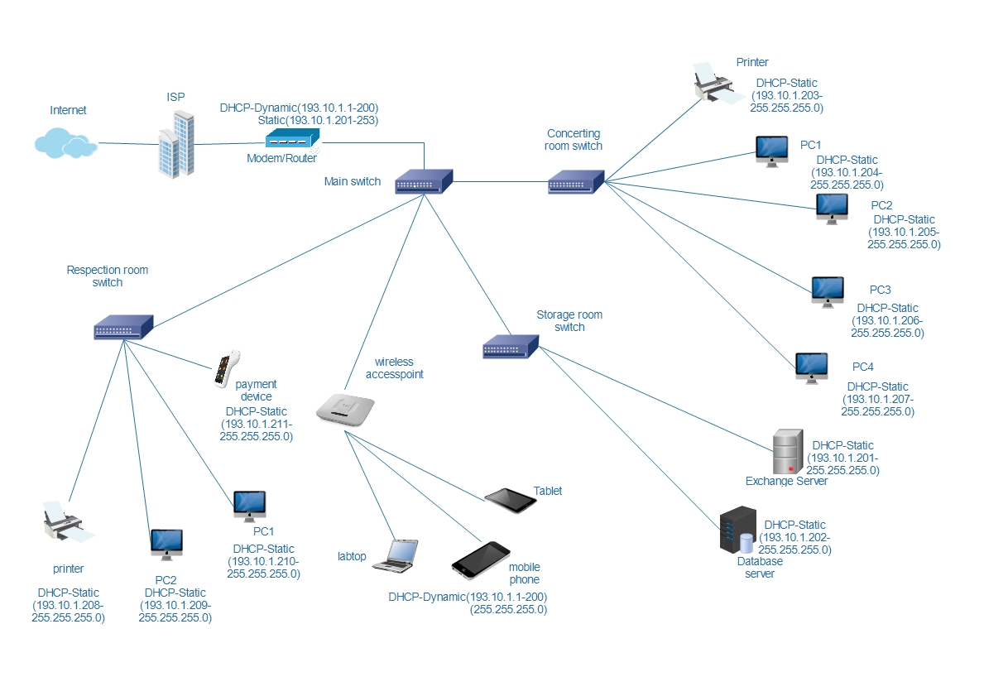

Fig(4.a.1)

## (b)

## (c)

## (d)Local Price and Specification of Hardware and Software

TASK-5

# Task 5: Telephony

## (a)What is VOIP?

## (b)

## (c)

# CONCLUSION

In conclusion

# REFERENCE